**Project Design Phase-II Data Flow Diagram & User Stories**

|  |  |
| --- | --- |
| Date | 9 October 2022 |
| Team ID | PNT2022TMID26125 |
| Project Name | Inventory Management System for Retailers |
| Maximum Marks | 4 Marks |

**Data Flow Diagram:**

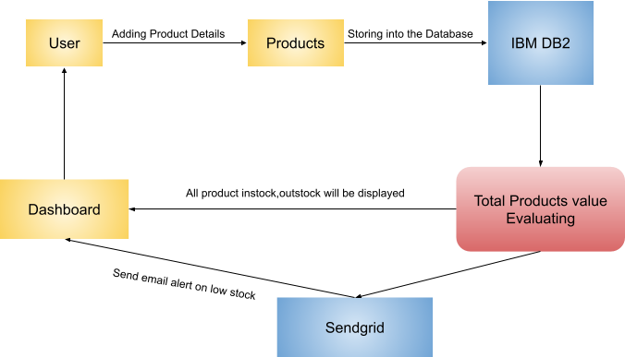

**User Stories:**

|  |  |  |  |  |  |  |
| --- | --- | --- | --- | --- | --- | --- |
| **User Type** | **Functional**  **Requirement**  **(Epic)** | **User Story**  **Number** | **User Story / Task** | **Acceptance criteria** | **Priority** | **Release** |
| Retailer | Registration | USN-1 | As a user, I can register for the application by entering my email, password, and confirming my password. | I can access my account / dashboard | High | Sprint-1 |
|  |  | USN-2 | As a user, I will receive confirmation email once I have registered for the application | I can receive confirmation email & click confirm | Medium | Sprint-1 |
|  | Login | USN-3 | As a user, I can log into the application by entering email & password | I can access my account / dashboard | High | Sprint-1 |
|  | Dashboard | USN-4 | As a user, I can view the stock list and suppliers list | Once I log in to the system, I can able to view the stocks | Medium | Sprint-1 |
|  | Items | USN-5 | As a user, I can add the items. | I can create a new type of item | High | Sprint-2 |
|  |  | USN-6 | As a user, I can see the items | I can be able to see the items that can be added to the inventory | Low | Sprint-2 |
|  | Inventory | USN-7 | As a user, I can add the items to inventory. | I can add items to the inventory with quantity | High | Sprint-2 |
|  |  | USN-8 | As a user, I can see the items in the inventory. | I can see the inventory items with quantity | Low | Sprint-2 |
|  | Indication | USN-9 | As a user, I can be able to receive indication | I receive a notification when the stock running  low | High | Sprint-3 |
|  | Location | USN-10 | As a user, I can be able to see items from a particular store location | I can be able to make purchase from a particular location | Medium | Sprint-3 |
|  |  | USN-11 | As a user, I can add a new location of my store | I can be able to add new store locations | Medium | Sprint - 3 |
| Customer | Purchase | USN -12 | As a customer, I can be able to purchase good from the particular location of the store | I can able to purchase from the store | High | Sprint - 4 |
| Retailer &  Customer | Deployment | USN-13 | As a user, I can access the software in the web | I can access the software in web | High | Sprint -4 |